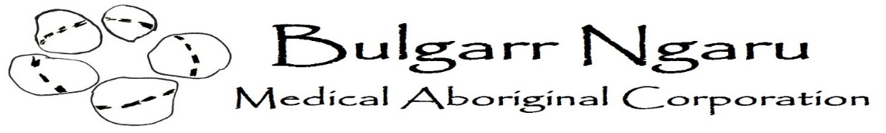
Registered Nurse: Part-time or full-time position
Bulgarr Ngaru Medical Aboriginal Corporation is a not-for-profit Aboriginal Community Controlled Health Organisation looking for a passionate and caring Registered Nurse to join our accredited health service in Casino NSW.
Monday to Friday with no after hours, no shift work or weekend work. Option to salary package up to $15,899 per annum
Essential Criteria:
- Current registration with AHPRA
- Covid-19 vaccinated in compliance with mandatory government requirements
- Current NSW Working with Children Check
- Current National Police Clearance
- Computer literacy
- Full valid working rights within Australia
- Current unrestricted Drivers Licence
- Minimum 3 years post-graduate experience
- The ability to work as an active member of a team.
- Importantly, you'll be a collaborative team player with outstanding communication and interpersonal skills and the ability to adapt your communication style to work effectively with people from a wide range of cultures and backgrounds.
Desirable
- Previous experience in an Aboriginal Community Controlled Organisation or in General Practice
- Immunisation Certificate and /or Women’s Health qualifications
- Knowledge of and experience with Practice Incentive and Service Incentive Payments including Health Assessments, Care Plans, Diabetes Cycles of Care, and Asthma programs would be well regarded.
Responsibilities:
- General nursing duties
- Wound care management
- Patient education
- Assisting doctors with minor procedures
- ECG
- Spirometry
- Immunisations including COVID vaccination
- Chronic disease management including GPMP, TCAs and Cycle of Care
- Recall and reminder management
- Aboriginal and Torres Strait Islander Health
- Health promotion and screening
- Support Accreditation and CQI
Please address the selection criteria above and send all applications and a copy of your CV to hr@bnmac.com.au
All enquires to Chris Clark : Ph 02 6662 3514 or cclark@bulgarr.com.au

